Lookout Point Country Club Limited
209 Tice Road, PO Box 709, Fonthill, ON, L0S 1E0
Phone 905-892-2639 Fax 905-892-4984
Website: www.lookoutpointcc.com
~ Congratulations on Your Engagement! ~

Thank you for considering Lookout Point Country Club Ltd. as the location to host your reception. We have the most picturesque view in all of the Niagara Peninsula and each season presents us with different colours, backdrops, and wildlife sightings. Our newly renovated, breath-taking facility is able to accommodate groups of 10 to 30 in the private atmosphere of the Travis Room and larger groups of 50 to 225 in the McInnis Hall.

Our Culinary Team prepares all meals using the influence of the season to add to your special day. Comprised of local produce and passion, the presentation is sure to delight. Our personal Events Coordinator will look after all of the details leading up to and including the time of your event to allow you to relax & enjoy your evening. Our professional staff is committed to providing first-class service and attending to all of your needs to ensure your event runs smoothly.

In this package, we provide you with all of the answers to your questions and leave no divot unturned! While we intend to provide you with guidelines on meal selections, room décor & set-up, we are here to provide a service and accommodate your wishes. Our Events Team will be happy to work with you in designing a menu & event specific to your needs. Our number one goal is to ensure that your special evening is organized just the way you dreamed!

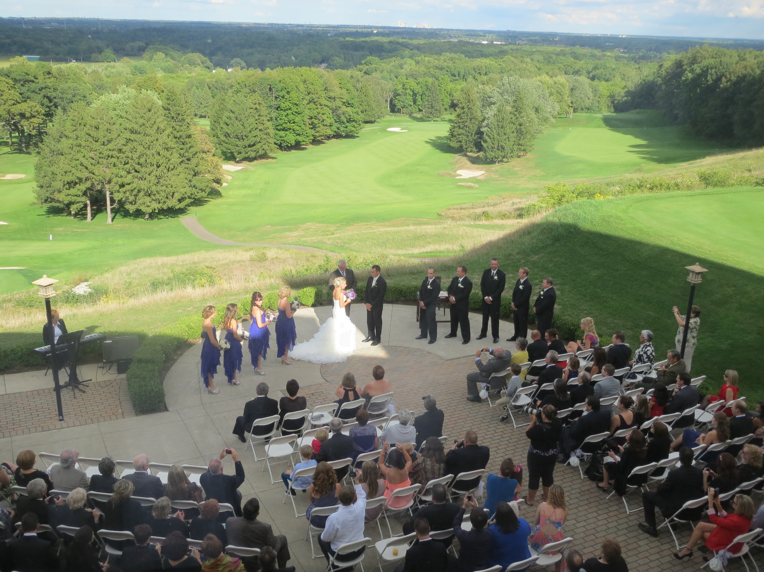
Wedding Information Guide
Frequently Asked Questions & Answers for you:

Q How many people can your Hall accommodate?
A McInnis Hall is licensed to accommodate approximately 250 people but our experience has shown 140 to 180 to be a comfortable number. These figures are general and dependent upon the format of your evening (location of head table, additional tables, buffet vs. plated, DJ set-up, etc.).

Q Do you have examples of different seating plans?
A We will provide you with different seating plans that will give you an idea on room set-up.

Q Is your facility wheelchair accessible?
A The upper level is wheelchair accessible and is equipped with washroom facilities. The lower level of the facility is also wheelchair accessible. However, there is no elevator or interior ramp linking the two levels.

Q Am I allowed to decorate the hall?
A This is your evening & we are certain that you will want to add personal touches or theme decorations to the hall and tables. We only ask that these be temporary decorations (we do not allow confetti, nails, screws, tacks, scotch tape, hooks, staples or anything damaging or permanent to be inserted into any equipment, furniture or structure). You will need to contact your Events Coordinator to arrange a time to decorate.

Q How late is the facility available and are there overtime charges?
A Bar service & entertainment will cease at 1:00am (last call @ 12:30am). The building will be locked & armed at 2:00am. Please keep this in mind when arranging for transportation, gift collecting, DJ services and general clean up. A surcharge of $25/employee (per half hour) will apply if any of LPCC’s staff are required to stay past 2:00am.

Q Do you have children’s meals & pricing?
A For children six (6) to eleven (11) years of age, a reduced price is available. Children 5 & under eat free.

Q. Do you allow us to bring in our own wine?
A This is allowed, however, we charge a corkage fee of $20 per bottle.

Q Do you allow on-site ceremonies?
A If available, the first tee or the back patio may be rented for an outdoor ceremony with an additional charge (see Additional Expenses). Please be reminded that outdoor ceremonies require a contingency plan should the weather not be favourable. There are specific parameters surrounding ceremonies and these details will be negotiated separately.

Things you will want to know…
Renting the Hall(s): When renting the McInnis Hall (Banquet Room) you have rented the upper level of the facility. This includes the following areas: the upstairs banquet room (McInnis Hall), the bar & the receiving area, the soft seating area, the front (parking lot) patio, and the Men’s & Ladies’ washroom facilities. * The Ladies Locker Room is a private, member’s only area. The Hall has a minimum of 110 people. If you do not make this number a $650 room charge will be applied.

Ceremony: It is difficult for LPCC to close the golf course, clubhouse and/or patio areas to the entire membership so, if you are interested in an on-site ceremony, there are terms, conditions, and fees separate from a standard booking (see Additional Expenses).

Photographs: There are several areas that would serve as great backgrounds for your wedding day photographs. We would like to meet with your photographer well in advance to review the areas available to you. The first tee and the practice putting green are available for photographs, however due to safety & privacy issues, the actual golf course is not.

Catering: We are a private golf & country club that employs several professionals experienced in their respective fields. We do NOT allow private caterers to cook and/or provide catered meals for your event. Should you require anything more than what Lookout Point can provide, we will negotiate a service charge. No outside food or drink is allowed to be brought into Lookout Point.

Menu Prices: In order to allow for unseen market conditions, menu prices are subject to change without notice. All prices are exclusive of 13% HST & 18% Gratuity.

Candles & Open Flames: All candles must be housed in tempered glass holders (i.e. hurricanes) with the top of the flame at least 2“ below the top of the holder. Tapers or votives without proper holders are not permitted. Pyrotechnics (smoke / fog machines, sparklers, fireworks) of any sort are prohibited.

Confetti, Rice, Sparkles & Glitter: These are not permitted on Lookout Point property. In order to avoid confusion, anything not listed but similar to the above items, should be cleared with the General Manager or Events Coordinator prior to being used.

Damage to Lookout Property: Lookout Point will add to the final bill any damage, missing property or any extra cleaning that may be required after your event. (Cleaning charges may vary depending on the extent or severity of the clean-up). Cleaning charges start at a flat rate of $75
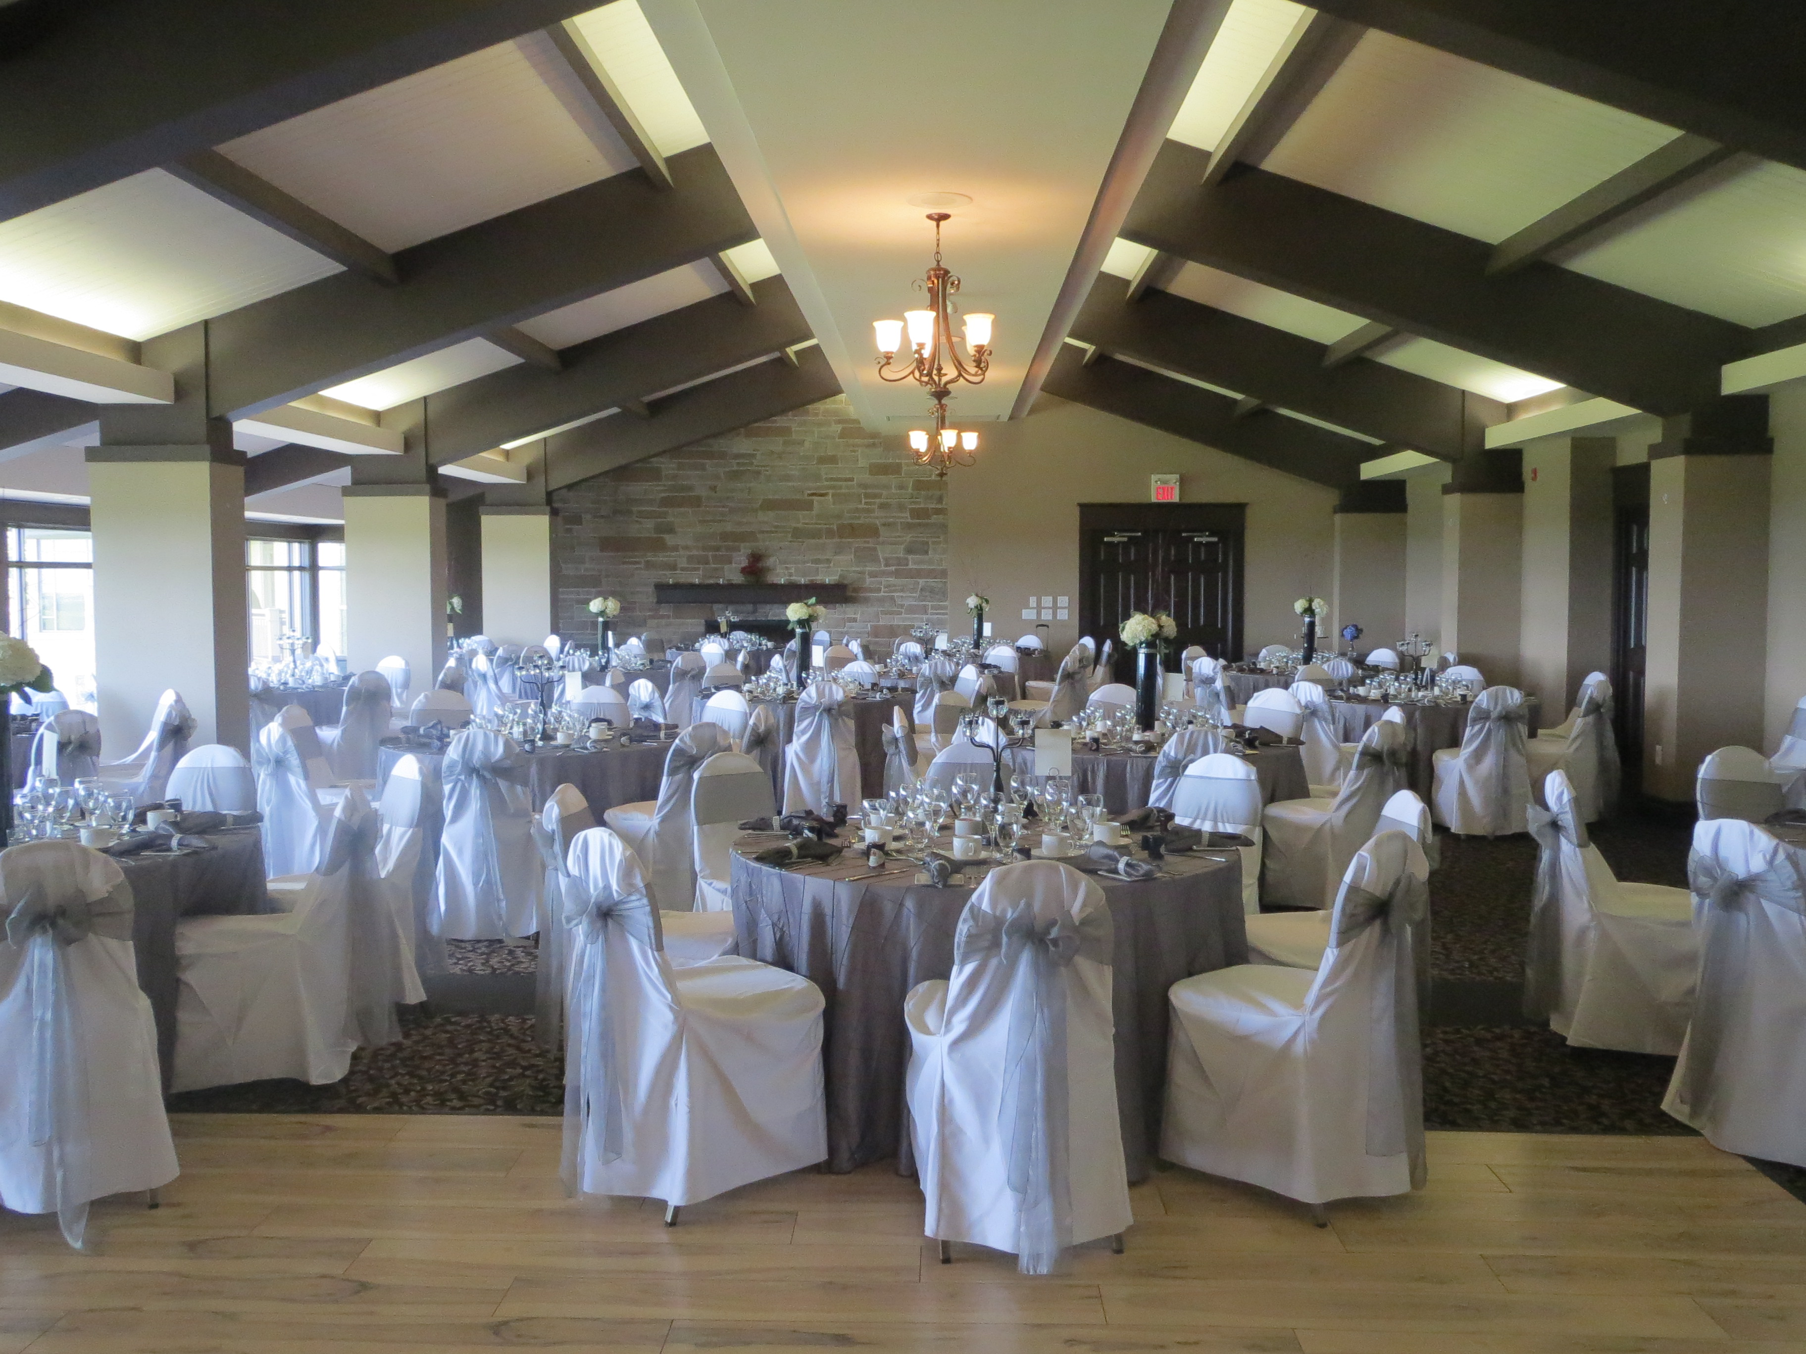
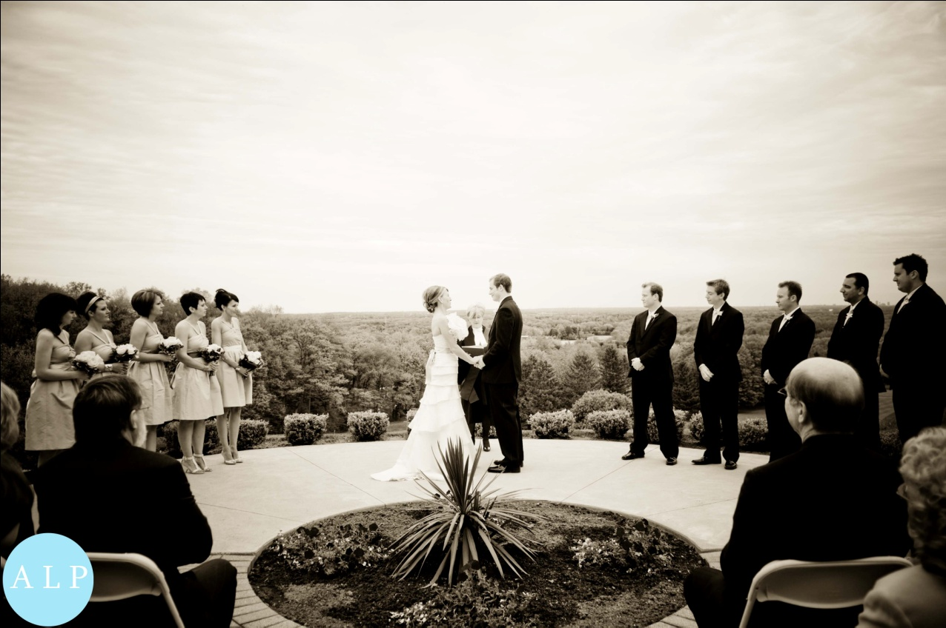

Services & Amenities…

The following services & amenities are standard with your booking & included in your meal price:

- Head table, registration table, gift table, cake table.

- Microphone & podium, local telephone calls.

- Personalized Event Coordination.

- Courteous & professional wait staff for complete set-up & service.

- Ample free parking (overflow parking available across the street).

- All tables will be fully set for plated service.

Things Lookout Point would like to know…
In order for your day to run smoothly & without error,
here is a list of things we would like you to provide via a detailed agenda:

- When is your decorator arriving to set-up?

- When is your DJ/Entertainment coming in to set-up?

- When is your wedding party arriving?

- When are your guests arriving?

- Are you having a rehearsal on-site?

- Where will your seating plan be posted?

- When is your wedding cake being delivered?

- How long are your speeches scheduled?

- Do you have any special requests?

- Do any of your guests have dietary / allergy restrictions?

- What outside vendors/suppliers will you be using (i.e. florist, decorator, photographer)?
Contact Us…
905-892-2639

Account Manager:
Claire Legarde claire@lopcc.com Ext. 222

Food & Beverage Manager
Patti Klenavic-Croft patti@lopcc.com Ext. 237
Additional Expenses…
Please find a listing of items not included with your meal price:

SOCAN & RE-SOUND Fees: SOCAN (Society of Composers, Authors & Publishers) and Re:sound (Music Licensing Company) each require that we collect a copyright tariff when musical performances (including D.J.) are held. The Tariff fees are as follows:

SOCAN/Re-sound: $62.64 (100 guests or less) With Dancing
$31.31 (100 guests or less) No Dancing
$90.12 (101 + guests) With Dancing
$45.02 (101 + guest) NO Dancing

Minimum(s): Please note, the main hall has a minimum of 110 people. If you do not make this number a $650 room charge will be applied. Holiday Weekend Weddings may require minimums and/or additional Labour Fees may be applied.

On-Site Ceremonies: If the room and space is available on your requested date, we do allow for an on-site ceremony. Outdoor ceremonies with reception take place at 4:30pm and may be a maximum one (1) hour in length. Glassware or china will not be permitted on patio(s) during the ceremony.

First Tee $1000.00 (With Reception)
First Tee $1500.00 (Ceremony Only)
Lower Foyer $600.00 (With Reception)

Ceremony Fee does not include chair rental.

Chair Rental: If you require additional chairs (white folding chairs or white bistro chairs) for an on-site ceremony, we will coordinate rental, delivery, set-up & return. The cost is $4.00 per chair.

Terms & Conditions

The following information and details outline the various terms and conditions that accompany your application and contract.

- Menu, bar and function details must be finalized in writing at least 14 days prior to your event.

- The guaranteed number of persons attending must be confirmed at least 7 days prior to your event. You will be billed for this number or the number in attendance, whichever is greater.

- Final payment is due 5 days prior to your function (weekend days are included – i.e. Saturday Event, payment due Thursday).

- Late payments are subject to a 4% service charge (any part thereof).

- N.S.F. Cheques or declined credit card payments are subject to a 4% service charge.

- All food, beverages, corkage fees and sundry items are subject to 13% HST and 18% gratuity. (Please note – HST is paid on the gratuity).

- Any theft, damage or excessive cleaning to Club property will result in additional charges to your final invoice & is the responsibility of the individual listed on the signed contract.

- Lookout Point Country Club, Limited is not responsible for lost, stolen or damaged items (anywhere on Club property – inside or outside), nor are we responsible for locking or securing valuable items.

- Lookout Point is serious about legal issues and will not serve alcohol to minors, abusive guests, guests who may be intoxicated or under the influence of drugs (prescription or otherwise). In addition, Lookout Point reserves the right to remove such guests from the premises without penalty. Lookout Point is committed to responsible alcohol service and guests should be ready to provide proper age identification when requested. Inclusive package does not allow for “shots”. All alcoholic drinks must be mixed.

- All bookings are considered tentative and therefore subject to cancellation until a formal contract (outlining ALL terms & conditions) has been signed and submitted with a valid credit card and the appropriate deposit.

- All prices (with the exception of the all-inclusive packaging price) are subject to applicable taxes, corkage fees, and service charges. All prices are set well in advance & are subject to change (without notice) if circumstances arise beyond our control.

- Lookout Point Country Club, Limited reserves the right to change, alter or amend any of the information in the menu packages, terms & conditions, methods of payments, rules & regulations of the Club etc. at any time, without notice or penalty.

- Food & Beverage and/or Bar Minimums may apply to weekend functions.

Terms of Payment

Our menu prices are subject to change without notice but will be confirmed 60 days before your event. Event Functions are subject to the following deposits based on the estimated total of your special event.

Methods of Payment

The following are methods of accepted payment: A Personal Cheque, debit, online banking (made through your bank institution using Lookout Point Country Club as a payee and account number x900) or Credit Card (Visa or MasterCard). You will be required to post a valid credit card on file as a security measure. The credit card will not be charged without your authorization unless there are outstanding charges, damage, theft or additional cleaning fees. If using a credit card, a 2.5% Administrative Fee will apply.

$1,000 Deposit (Non-refundable): Due at time of signing.

Date: __________ Deposit Amount: _______________ Signature: _________________________

50% of Estimated Invoice: Due 60 days prior to your function.

Date: __________ Est. Amount: _______________ Signature: ______________________________

75% of Estimated Invoice: Due 30 days prior to your function.

Date: __________ Est. Amount: _______________ Signature: ______________________________

Remaining Balance is due no later than 5 days prior to the day of the event.

Date: __________ Balance: _______________ Signature: ______________________________

****Lookout Point Country Club is asking for permission to post on our social media links.
YES___ NO___

* Cancellation Policy: Once a payment has been made (according to the above schedule),
it is no longer refundable.

Payment must be made to: Lookout Point Country Club, Limited.
209 Tice Road, P.O. Box 709, Fonthill, ON L0S 1E0

Lookout Point Country Club, Limited

~ Rental Contract ~

To reserve a date and time for your reception to be held in McInnis Hall, please fill out, sign, and return this contract with your deposit.

Date of Reception: ____________________. Will you require rental of the First Tee for a ceremony? _______

Estimated # of guests: _________.

I, _________________________ understand that if the scheduled event is cancelled by me or anyone associated with my event, the deposit of ________________ that has been paid, is non-refundable. I have also read the entire 2020 Wedding Package and agree to abide by all the policies and payment terms (written and/or verbal) enclosed.

Details:
________________________________________________________________________________________________________________________________________________________________________________________________________________________________________________________________________

I further agree that:

Lookout Point Country Club, Limited reserves the right to change without notice, any policy or procedure that has been communicated either verbally or in writing. I understand that multiple events may be held at Lookout Point Country Club, Limited on or near my event date. I agree to hold Lookout Point Country Club, Limited harmless from any liability resulting from acts of omission of Lookout Point Country Club, Limited, their agents, employees, independent contractors, visitors or other persons acting on their instruction or with their consent. A representative acting on behalf of Lookout Point may take pictures that will be used as promotional / marketing material for future events. These materials may be posted on Lookout Point’s website or copied to a disc for public viewing purposes. The individual below is responsible for full payment, damages, theft, cleaning charges and all other outstanding charges.

________________________________________ _______________________ _______________________
Signature Printed Name Date

______________________________________________________________________________________
Street Address / City / Province / Postal Code

____________________ __________________ ____________________________________
Phone Number Mobile Phone Email address

______________________________ ______________
Credit Card # (Visa or MasterCard) Expiry Date
Additional Notes for your Event…

